WEEK 8:

For the entire Week 8, we will be using Ureka Server. Let me explain what that is.
Imagine that we have to get a plumber for a task (Service). So there could be many plumbers in different locations. Imagine having to call EVERY plumber, asking for their address, time and availability. Tedious right?
So, in place of that, we go to a middleman. Someone certainly saw this problem and made a directory where when we request for a service, they take care of the address of the plumber and get us in contact with them.
Similarly, in Spring, there are multiple microservices that are hard to navigate by ourselves. So what we do is, we go to the EUREKA SERVER (Found by Netflix btw) that handles all this port addressing and helps us to locate, check availability and connect!
We will create a new spring starter project for this: Discover-MS
Dependencies added: Spring development tools, Eureka Server
Week 8.1:
After creating the project, we go to DiscoverMsApplication.java and write the following:
package com.fsad;

import org.springframework.boot.SpringApplication;
import org.springframework.boot.autoconfigure.SpringBootApplication;
import org.springframework.cloud.netflix.eureka.server.EnableEurekaServer;

@EnableEurekaServer
@SpringBootApplication
public class DiscoverMsApplication {

public static void main(String[] args) {
SpringApplication.run(DiscoverMsApplication.class, args);
}

}

Then we open application.properties:
Add this:
spring.application.name=Discover-MS
server.port=8761
eureka.client.register-with-eureka=false
eureka.client.fetch-registry=false

Now, run DiscoverMSApplication.java as a spring app.
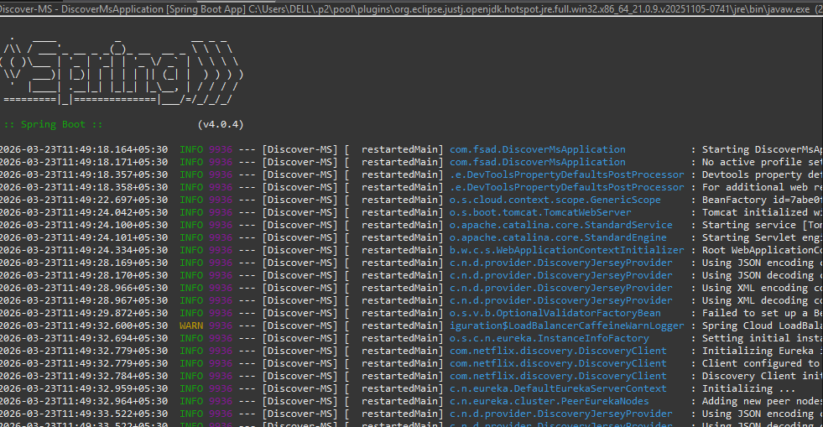

And upon entering this:
http://localhost:8761
In the browser, we get:
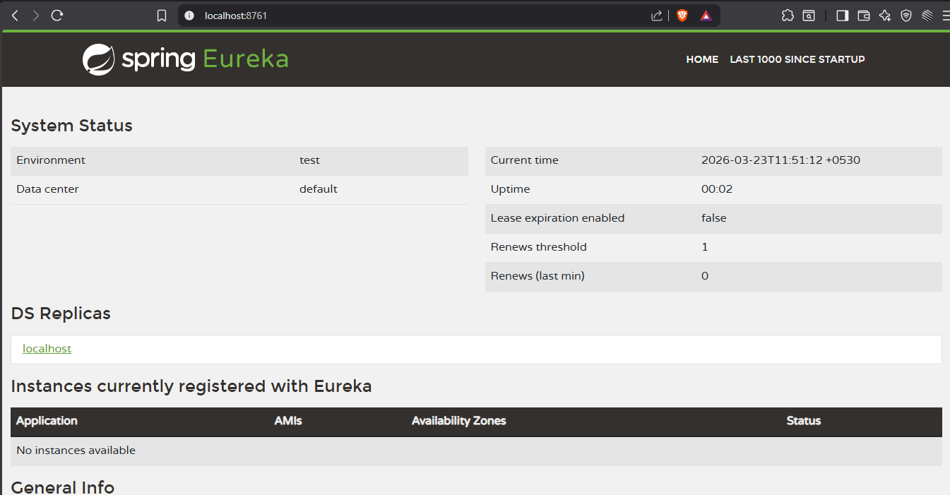
The eureka dashboard!

Now we need to create 2 microservices.
For that we create a new Spring Starter Project:
User-MS
Dependencies: Spring Web dev tools, Eureka Discovery Client, Spring Web
Now to the application.properties of this project, write:
server.port=8082 //Since 8081 is being used by fsad project
spring.application.name=User-MS
eureka.client.service-url.defaultZone=http://localhost:8761/eureka/

Now we open UserMsApplication.java and do the following changes:
package com.fsad;

import org.springframework.boot.SpringApplication;
import org.springframework.boot.autoconfigure.SpringBootApplication;

@SpringBootApplication
public class UserMsApplication {
public static void main(String[] args) {
SpringApplication.run(UserMsApplication.class, args);
}
}

Now, we need to ensure we run both the UserMsApplication and the DiscoverMsApplication as spring apps simultaneously.
When we reload the server localhost link we get the UserMS as an instance:
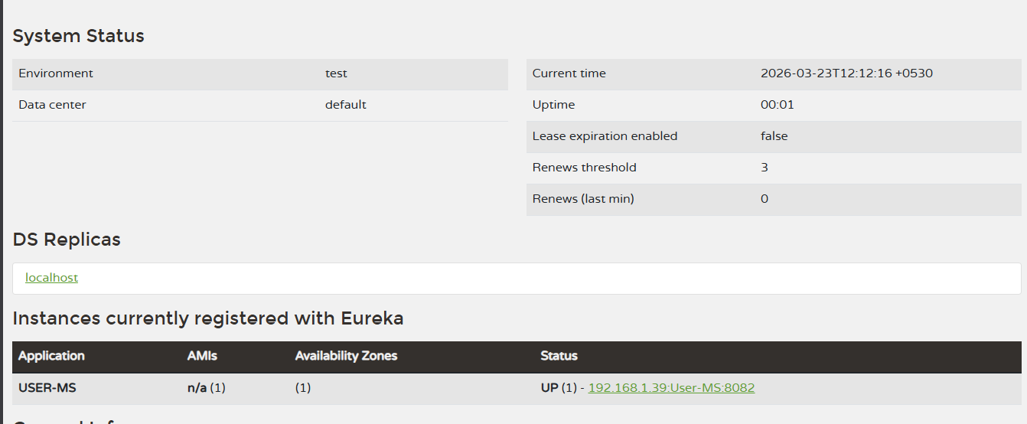

Let us try to create another instance in the same way!
Accounting-MS will be the new project (That will later on become the instance). Let us create that!
Dependency – same as the previous: Spring Web dev tools, Eureka Discovery Client, Spring Web
In ITS application.properties, we write the following, changing the port number to 8083.
server.port=8083
spring.application.name=AccountMng-MS
eureka.client.service-url.defaultZone=http://localhost:8761/eureka/

Now we run the app along with DiscoverMs as we did earlier, and we see 2 instances now.

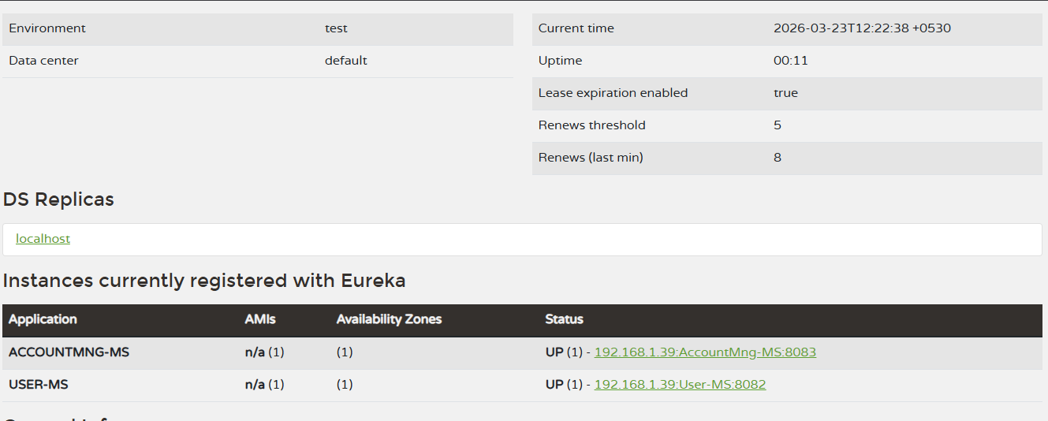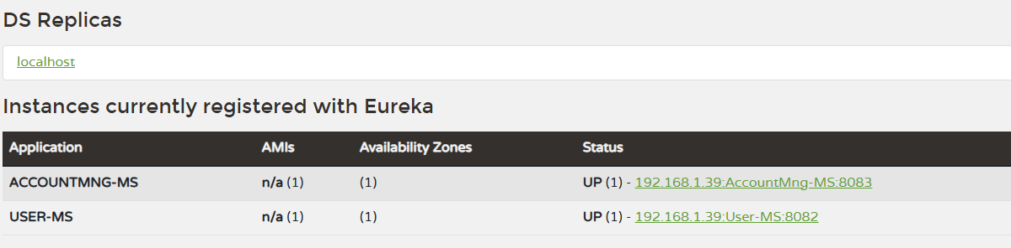

That was task 8.1 and 8.2.

Task 8.3:
API Gateway is like a security guard at the entrance.
Instead of clients talking to each microservice directly, ALL requests go through ONE gateway which routes them to the right service.
Client → API Gateway → USER-MS
→ ACCOUNTMNG-MS
So instead of knowing localhost:8082 for User and localhost:8083 for Account, client just hits localhost:8084 and Gateway handles the rest!
API Gateway is a single entry point that routes client requests to appropriate microservices, providing load balancing, security, and routing in one place.

We create a new Spring starter Project now called: API-Gateway
Dependencies: Gateway, Eureka Discovery Client, Spring Boot DevTools
NOTE: Do NOT add Spring Web. That will Conflict with the Gateway.
Spring Boot 4.x introduced a new MVC-based Gateway with completely changed APIs (spring-cloud-starter-gateway-server-webmvc) that is incompatible with the traditional reactive Gateway routing. Spring Boot 3.5.12 uses the stable reactive Gateway (spring-cloud-starter-gateway) with well-established routing APIs.Thus, we are required to change the version of spring from dropdown menu to a lower spring boot version (3.15 here).

Hence, we open application.properties in the API-Gateway project and do the following:
server.port=8084
spring.application.name=API-Gateway
eureka.client.service-url.defaultZone=http://localhost:8761/eureka/

To establish configurations, We make a class called GatewayConfig.java and add the following content to it:
package com.fsad;

import org.springframework.cloud.gateway.route.RouteLocator;
import org.springframework.cloud.gateway.route.builder.RouteLocatorBuilder;
import org.springframework.context.annotation.Bean;
import org.springframework.context.annotation.Configuration;

@Configuration
public class GatewayConfig {

@Bean
public RouteLocator routes(RouteLocatorBuilder builder) {
return builder.routes()
.route("user-service", r -> r
.path("/users/**")
.uri("lb://USER-MS"))
.route("account-service", r -> r
.path("/accounts/**")
.uri("lb://ACCOUNTMNG-MS"))
.build();
}
}

For these changes to work, we need a few dependencies. We will add that into the pom.xml file.
<dependency>
<groupId>org.springframework.cloud</groupId>
<artifactId>spring-cloud-starter-gateway</artifactId>
</dependency>

This is actually a replacement to:
<dependency>
<groupId>org.springframework.cloud</groupId>
<artifactId>spring-cloud-starter-gateway-server-webmvc</artifactId>
</dependency>

Once we run this as spring app and go to:
http://localhost:8761/
We get this page indicating that it is also an instance now!
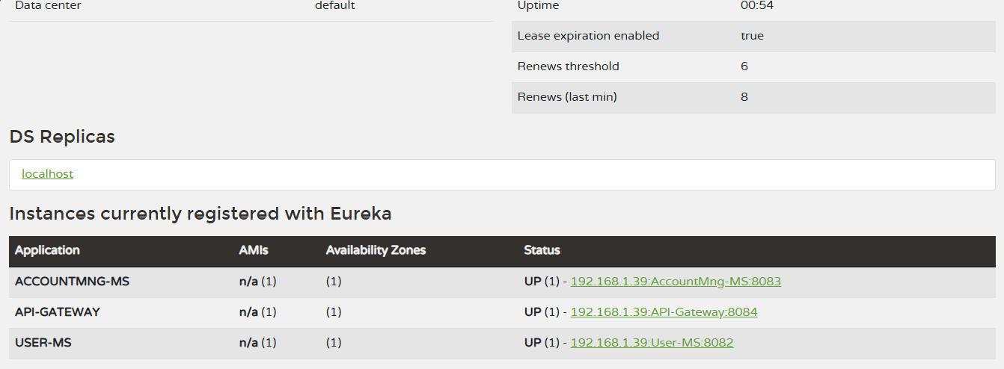

Then we make the following changes in UserMsApplication.java
package com.fsad;

import org.springframework.boot.SpringApplication;
import org.springframework.boot.autoconfigure.SpringBootApplication;
import org.springframework.beans.factory.annotation.Value;
import org.springframework.web.bind.annotation.GetMapping;
import org.springframework.web.bind.annotation.RestController;

@SpringBootApplication
public class UserMsApplication {
public static void main(String[] args) {
SpringApplication.run(UserMsApplication.class, args);
}
}

@RestController
class UserController {

@Value("${server.port}")
private String port;

@GetMapping("/users")
public String getUsers() {
return "Hello from User-MS on port: " + port;
}
}

We go to the url:
http://localhost:8082/users
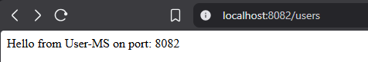
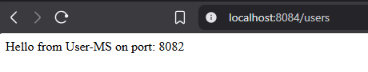

This marks the end of task 8.4.

Task 8.5:
Inter-service communication using JMS instead of REST
So far all our microservices talk to each other via REST (HTTP calls). JMS is a completely different way of communication!
The difference:
REST (what we did before):
Service A → directly calls → Service B
"Hey Service B, process this NOW and give me a response!"
Synchronous — A waits for B to respond!
JMS (what we're doing now):
Service A → drops message in QUEUE → Service B picks it up when ready
"Hey Queue, tell Service B this when it's free!"
Asynchronous — A doesn't wait! Like dropping a letter in a mailbox! 📬
ActiveMQ = the mailbox/message broker that holds the queue!
What we're building:
- One service sends a message to a queue
- Another service listens to that queue and processes it
- They never talk directly — only through the queue!
"JMS enables asynchronous inter-service communication through a message broker. Services are completely decoupled — sender doesn't need receiver to be available at the same time."

Hence, for this we will be downloading ActiveMQ.

Upon successful installation by running the activemq.bat file in the bin of the extracted zip file, we go to cmd and write:
cd C:\Users\DELL\Downloads\apache-activemq-6.2.1-bin\apache-activemq-6.2.1\bin
activemq.bat start
That way we get to install it. Once done, go to:
http://127.0.0.1:8161

And it opens as:
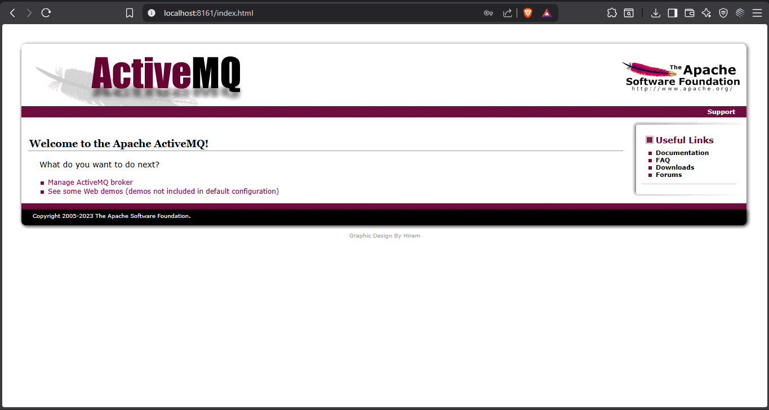

Now we create a new spring starter project:
JMS-MS
Dependencies:
- Spring Web
- Spring Boot DevTools
- Search ActiveMQ → Spring for Apache ActiveMQ 5
Open application.properties and write the following in it:
server.port=8085
spring.application.name=JMS-MS
spring.activemq.broker-url=tcp://localhost:61616
spring.activemq.user=admin
spring.activemq.password=admin
Now, create a class called MessageSender in it. Add the following:
package com.fsad;

import org.springframework.beans.factory.annotation.Autowired;
import org.springframework.jms.core.JmsTemplate;
import org.springframework.stereotype.Service;

@Service
public class MessageSender {

@Autowired
JmsTemplate jmsTemplate;

public void send(String message) {
jmsTemplate.convertAndSend("myQueue", message);
System.out.println("Sent: " + message);
}}
Create another class called MessageReciever:
package com.fsad;

import org.springframework.jms.annotation.JmsListener;
import org.springframework.stereotype.Component;

@Component
public class MessageReciever {

@JmsListener(destination = "myQueue")
public void receive(String message) {
System.out.println("Received: " + message);
}
}

Now, class JMSController:
package com.fsad;

import org.springframework.beans.factory.annotation.Autowired;
import org.springframework.web.bind.annotation.GetMapping;
import org.springframework.web.bind.annotation.RequestParam;
import org.springframework.web.bind.annotation.RestController;

@RestController
public class JMSController {

@Autowired
MessageSender messageSender;

@GetMapping("/send")
public String sendMessage(@RequestParam String message) {
messageSender.send(message);
return "Message sent: " + message;
}
}

Now we run that as a spring app:
Then this url: http://localhost:8085/send?message=HelloFromJMS
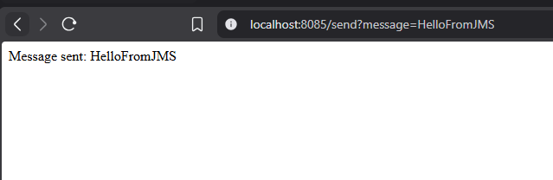
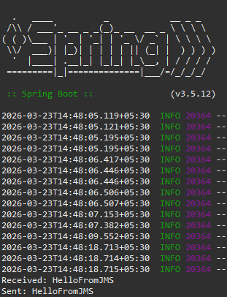
The above Screenshot from the Eclipse Console shows that the message being sent was received without us having to meddle with the localhost ports. This concludes week 8.

